Tanguy, Yves (1900-1955)

Yves Tanguy was a French painter and one of the principal members of the Surrealist group. His main artistic output consisted of oil paintings, characterised by abstract forms rendered three-dimensionally and set in elusive recessional space. His manner of painting was devised according to the Surrealist concept of automatism. Tanguy is well known for his contributions to numerous ‘exquisite corpse’ drawings made collectively with other Surrealists and also for his work based on the concept of the Surrealist *Objet (Object)* in the mid 1930s. Over many years, he was a regular illustrator for Surrealist publications, including works by André Breton, Benjamin Péret, and in the Surrealist journal *Minotaure*. During WWII in the early 1940s, Tanguy played a crucial role in bringing the Surrealist group to New York, an exodus that is perceived in the history of modernism as consequential to the development of Abstract Expressionism and the American school of modernist painting. During this period of activity in New York, the formal qualities of particular Surrealist paintings, such as the abstract works of Tanguy and Roberto Matta, proved inspirational for certain Abstract Expressionists’ formal explorations around colour, medium, perception, and sensation.

After leaving his native home in the town of Locronan, Brittany, Yves Tanguy moved to Paris in the early 1920s and entered the Surrealists’ social circle. By a progressive series of introductions with different Surrealists, at the end of 1925 he gained an audience with the group’s leader André Breton, and soon afterwards became officially affiliated with the group. As one of the first artists to join the Surrealists, within roughly a year of the publication of the first Surrealist Manifesto in 1924, he became one of the group’s main artistic representatives. He was given his first solo exhibition - *Yves Tanguy and Objects from America* - at the Surrealist Gallery in May 1927. This inaugural exhibition gave Tanguy a profile commensurate to major figures like Max Ernst and Man Ray, then at the forefront of Surrealist art.

Tanguy famously took up painting in 1923 after being inspired by seeing two of Giorgio de Chirico’s paintings in the window display of Paul Guillaume’s gallery. Quite contrary to the figurative style of de Chirico, Tanguy developed his painting practice out of the Surrealist concept of automatism. Psychic automatism was the driving concept behind all Surrealist activities. Breton conceived of Surrealism as an experimental psychoanalytical project for exploring the pure, unmediated ‘functioning of thought’, based on Sigmund Freud’s notion of the unconscious. To express or capture a manifestation of unconscious thought was the fundamental aim of Surrealism. To these ends, Breton himself had devised automatic writing, and André Masson had developed automatic drawing. Under the same rubric, Tanguy developed a method of automatic painting, which he upheld throughout his career. In his automatic procedure, he first applied his paints at random, without any conscious design. He then proceeded to clarify those initial marks into amorphous forms that they suggested to him, which he rendered three-dimensional within indeterminate recessional space that has often been likened to a kind of landscape.

Surrealism holds an anomalous reputation relative to Clement Greenberg’s formalist model for modernist painting, a painterly aesthetic focused upon the flat canvas surface. In many ways, Tanguy’s paintings re-engage with traditional Renaissance concepts of the painting as a window onto illusionistic space. In terms of modernism’s historical development, however, Surrealism has a very certain role. The Surrealist group’s relocation to New York to escape the Nazi occupation of France during WWII caused a definitive change in the structure of the modernist avant-garde. Their presence in New York has often been identified as a crucial factor in the emergence of a New York school of painting and, more directly, in the development of the American Abstract Expressionist group. As the first Surrealist artist to have left France for America, in November 1939, and aided by his wife and fellow artist Kay Sage (1898-1963), Tanguy was instrumental in establishing this Surrealist community in New York.

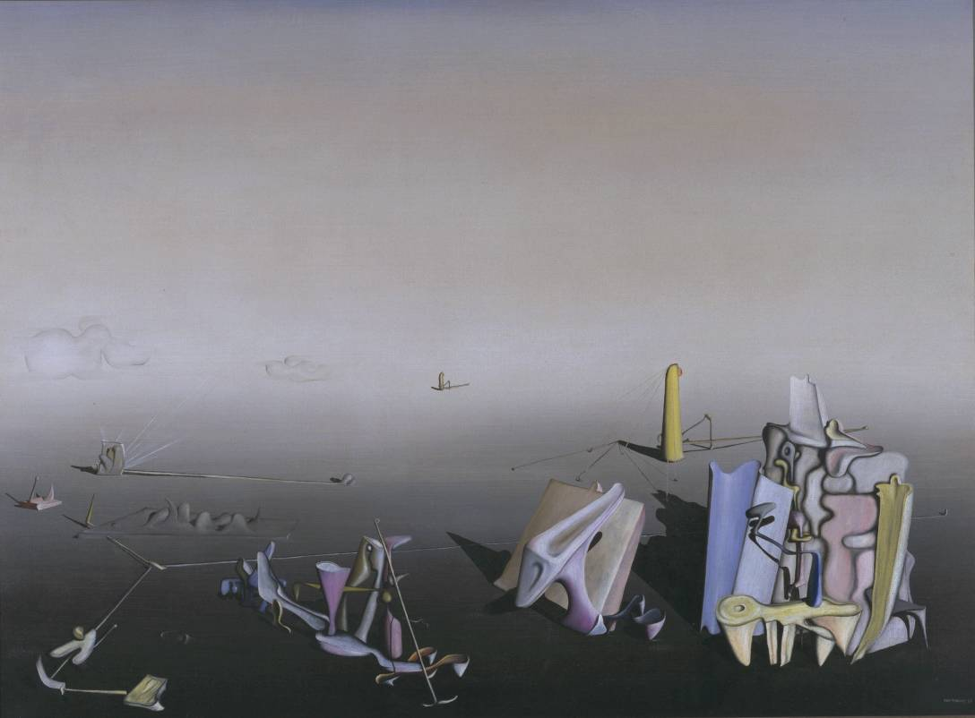

\* *Azure Day*, 1937, Tate Modern, London. <http://www.tate.org.uk/art/artworks/tanguy-azure-day-t07080>

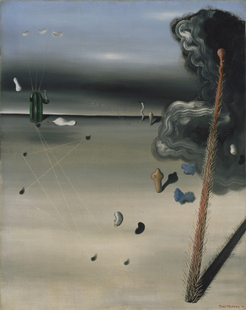

\**Mama, Papa is Wounded!*, 1927, The Museum of Modern Art, New York. <http://www.moma.org/collection/browse_results.php?criteria=O%3AAD%3AE%3A5804&page_number=12&template_id=1&sort_order=1>

References and Further Reading

* Cariou, André, *Yves Tanguy, l’Univers Surréaliste*, (Paris: Somogy, 2007).
* Durozoi, Gerard, *History of the Surrealist Movement,* trans. Alison Anderson, (Chicago; London: University of Chicago Press, 2002).
* Maur, Karin von, *Yves Tanguy and Surrealism*, ([Ostfildern : Hatje Verlag, 2001).](javascript:open_window(%22http://library.kcl.ac.uk:80/F/E8FS6Y9XRMB3JJXTGGF3IFKRJBAJPHI8EMXE53VRQ713UU7G4I-00070?func=service&doc_number=000469313&line_number=0009&service_type=TAG%22);)